**SPH3U 12.5 The Motor Principle**

1. **The motor principle**

|  |  |
| --- | --- |
| Faraday’s experiment: |  |

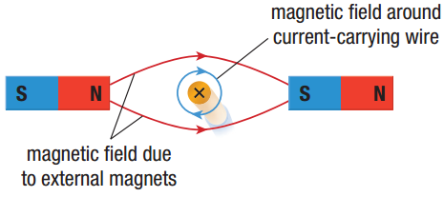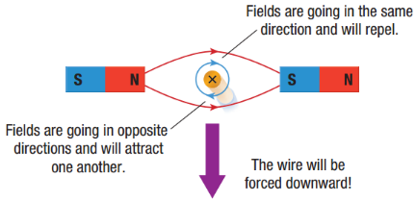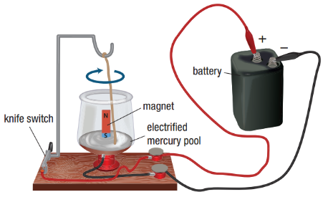

|  |  |
| --- | --- |
| The motor principle: |  |
| Right-hand rule #3: |  |

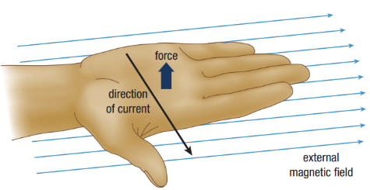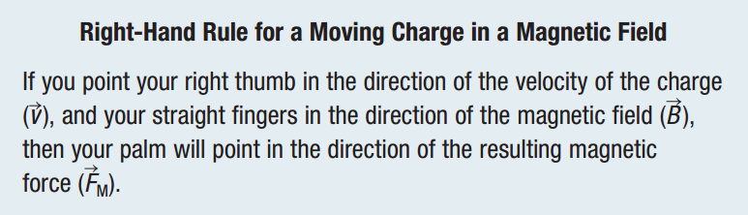

Draw the magnetic field lines of both the magnet and the conductor. Then determine the direction of the force on the conductor.

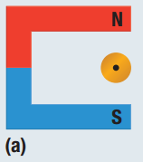 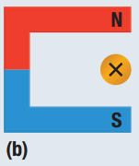 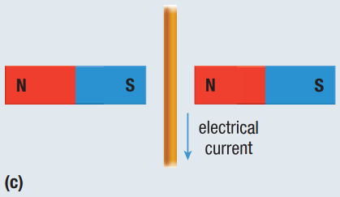

1. **The analog meter**

|  |  |
| --- | --- |
| The galvanometer: |  |

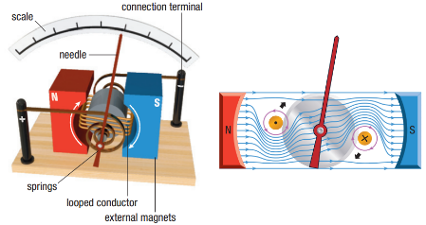

|  |  |
| --- | --- |
| Ammeter: |  |
| Voltmeter: |  |

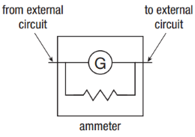 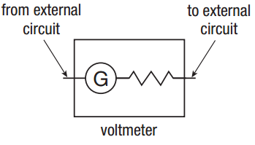

**Homework:** page 566: #1-3, 5-6